Organised by the Friends of Alton Abbey: Registered Charity No 284876
open days at Alton abbey
Saturday and Sunday June 9th & 10th 12 noon - 5.0pm
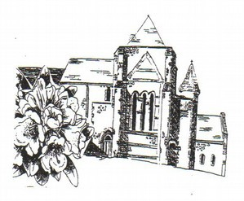
Admission £3 Tea and Cake £3
Lace making & Display of work BEAUTIFUL Stationary
pretty bantam chickens
Plants & Second-hand books for sale
Piano Recital 3pm Sunday 10th

Alton Abbey is signed off the A339, & is between Beech & Medstead
Friends of Alton Abbey, Alton Abbey, Abbey Road, Beech, Alton, GU34 4AP

